**Submit before 22nd Sep to earn 100 points**

PRO-C22: SUPPLY MISSION - 1

Assigned

Supply Mission - 1

**INSTRUCTIONS:**

**Goal of the Project:**

In Class 22, you learnt how to create a ball, respond to gravity, and make it fall, then enable it to bounce off the ground.  
  
In this project, you will have to practice and apply what you have learnt in the class and drop supplies and medical kits in the middle of a zombie apocalypse.

**Story:**

You are a sergeant on a military peacekeeping mission delivering essential medical supplies  
and food to a designated drop zone in a zombie infested city. The zombies don't know about  
this drop zone and couldn't care less about medicines.  
  
Because of the nature of the package content, you have ensured that you pack the supplies in a safety package which is soft and will take most of the impact.  
  
This package should bounce a couple of times, before coming to a stop.  
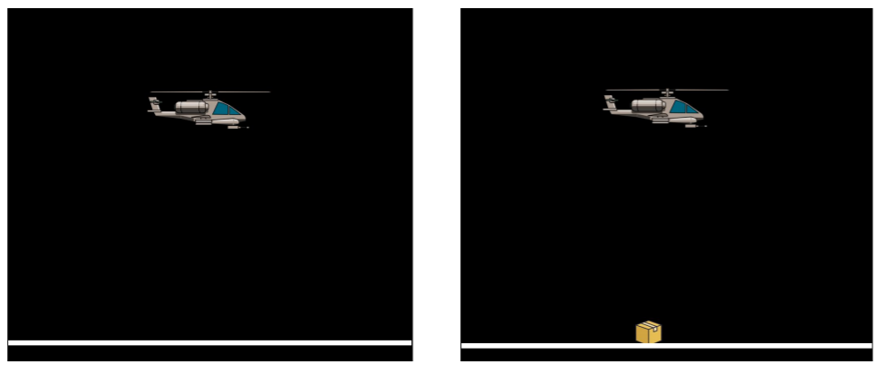

*This is just for your reference. We expect you to apply your own creativity in the project.

**Getting Started:**

1. Use the template on github, available for download on the following link:

<https://github.com/rupinwhitehatjr/SupplyMission/archive/master.zip>

1. **Unzip** this folder.
2. Rename the unzipped folder as **Project 22**.
3. **Import** this folder **into VS Code**.
4. Start editing your code in **sketch.js.**

**Specific Tasks to complete the Project:**

1. When the mission starts, you will see a helicopter, and the package is hidden behind the helicopter. This is done in code by design.
   * Whichever body is added to the world first is kept below the one which comes after it, thereby hiding the previously created bodies behind the newly created ones.
2. By default, the package will drop and bounce around like a ball. You have to prevent this.
3. On the press of the **down arrow key**, you have to drop the package. (See the hints section below on how to do this.)
4. Ensure that the package does not bounce more than three times, when it hits the ground.
5. Make sure the project works before you submit it.

*Refer to the images given above for reference.

**Submitting the Project:**

1. **Upload** your completed project to your own github account.

• Enable **Github** pages for the repository.

• Copy and paste the link to the github pages in the Student Dashboard against the correct class number.

**Hints:**

1. You can set the body from static to not-static by setting its **isStatic** property to **false.**
   * **Matter.Body.setStatic(< body Name >, false);**
   * Also see <https://brm.io/matter-js/docs/classes/Body.html#method_setStatic>

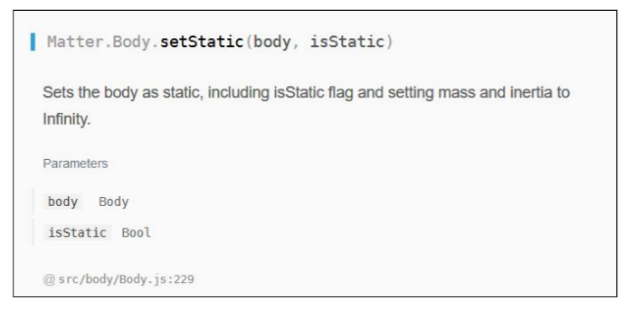

1. A lot of the code has already been written for you.
   * Please see the **setScale Method** of a sprite on how to change its sizing:

<https://code-dot-org.github.io/p5.play/docs/classes/Sprite.html#prop-scale>

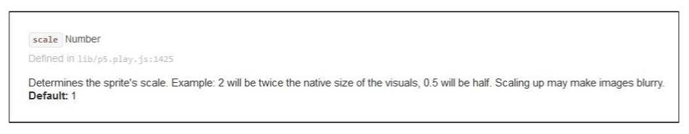

1. Sprites and Bodies behave a little differently.
   * For Sprites the x property is directly accessible through the sprite itself.
   * On the other hand, a Body has a position attribute which has the X and Y attributes.

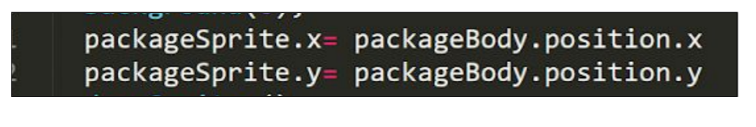

**REMEMBER… Try your best, that’s more important than being correct.**

After submitting your project your teacher will send you feedback on your work.

**Start Your Project**

Read all the instructions carefully to understand the project

Click on "Start Project" to go to the project playground and start your project

[**Start Project**](https://github.com/rupinwhitehatjr/SupplyMission/archive/master.zip)

**Submit Your Project**

Learn how to submit your project

Submit Project

**Class Summary**

This project is based on your last class PRO-C22

[**View Class Summary**](https://whjr-v2-prod-bucket.s3.ap-south-1.amazonaws.com/cb5506f3-ec4b-4d74-b4b2-525573310946.pdf)